**EX. NO: 1**

# IMPLEMENTATION OF CAESAR CIPHER

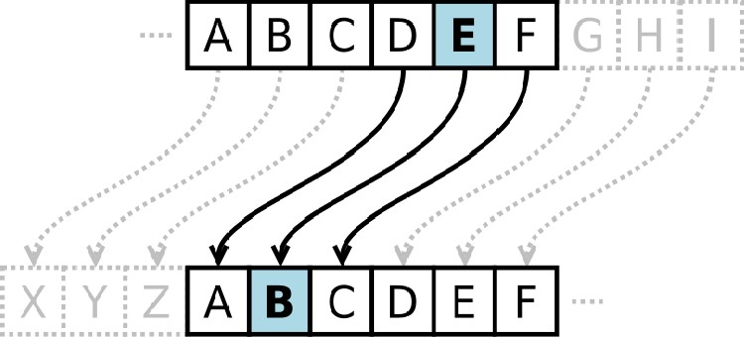

**AIM:**

To implement the simple substitution technique named Caesar cipher using C language.

**DESCRIPTION:**

To encrypt a message with a Caesar cipher, each letter in the message is changed using a simple rule: shift by three. Each letter is replaced by the letter three letters ahead in the alphabet. A becomes D, B becomes E, and so on. For the last letters, we can think of the alphabet as a circle and "wrap around". W becomes Z, X becomes A, Y bec omes B, and Z becomes C. To change a message back, each letter is replaced by the one three before it.

**EXAMPLE:**

**ALGORITHM:**

**STEP-1:** Read the plain text from the user.

**STEP-2:** Read the key value from the user.

**STEP-3:** If the key is positive then encrypt the text by adding the key with each character in the plain text.

**STEP-4:** Else subtract the key from the plain text.

**STEP-5:** Display the cipher text obtained above.

**PROGRAM: (Caesar Cipher)**

#include<stdio.h>

#include<string.h>

int main(){

char a[100];

int k;

printf("Enter the string : ");

scanf("%[^\n]s",a);

printf("Enter the key value : ");

scanf("%d",&k);

char alpha[]="abcdefghijklmnopqrstuvwxyz";

for(int i=0;i<strlen(a);i++){

for(int j=0;j<strlen(alpha);j++){

if(a[i]==alpha[j]){

j=j+k;

a[i]=alpha[j];

}

else if(a[i]==' '){

continue;

}

}

}

printf("Enter the Encryted value : %s\n",a);

for(int i=0;i<strlen(a);i++){

for(int j=0;j<strlen(alpha);j++){

if(a[i]==alpha[j]){

j=j-k;

a[i]=alpha[j];

}

else if(a[i]==' '){

continue;

}

}

}

printf("Enter the decrypted value : %s ",a);

}

**OUTPUT:**

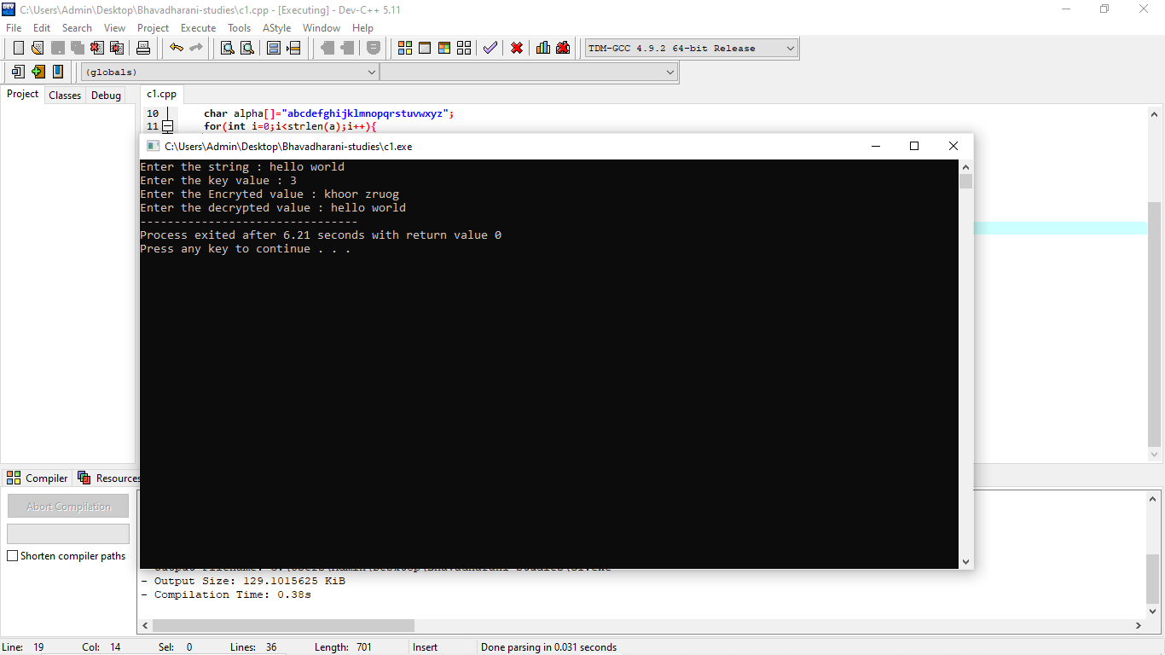

**RESULT:**

Thus the implementation of Caesar cipher had been executed successfully.

**EX. NO: 2**

**AIM:**

# IMPLEMENTATION OF PLAYFAIR CIPHER

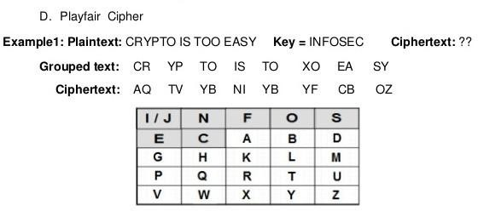

To write a C program to implement the Playfair Substitution technique.

**DESCRIPTION:**

The Playfair cipher starts with creating a key table. The key table is a 5×5 grid of letters that will act as the key for encrypting your plaintext. Each of the 25 letters must be unique and one letter of the alphabet is omitted from the table (as there are 25 spots and 26 letters in the alphabet).

To encrypt a message, one would break the message into digrams (groups of 2 letters) such that, for example, "HelloWorld" becomes "HE LL OW OR LD", and map them out on the key table. The two letters of the diagram are considered as the opposite corners of a rectangle in the key table. Note the relative position of the corners of this rectangle. Then apply the following 4 rules, in order, to each pair of letters in the plaintext:

1. If both letters are the same (or only one letter is left), add an "X" after the first letter
2. If the letters appear on the same row of your table, replace them with the letters to their immediate right respectively
3. If the letters appear on the same column of your table, replace them with the letters immediately below respectively
4. If the letters are not on the same row or column, replace them with the letters on the same row respectively but at the other pair of corners of the rectangle defined by the original pair.

**EXAMPLE:**

# ALGORITHM:

**STEP-1:** Read the plain text from the user.

**STEP-2:** Read the keyword from the user.

**STEP-3:** Arrange the keyword without duplicates in a 5*5 matrix in the row order and fill the remaining cells with missed out letters in alphabetical order. Note that

„i‟ and „j‟ takes the same cell.

**STEP-4:** Group the plain text in pairs and match the corresponding corner letters by forming a rectangular grid.

**STEP-5:** Display the obtained cipher text.

# PROGRAM: (Playfair Cipher)

**OUTPUT**

# RESULT:

Thus the Playfair cipher substitution technique had been implemented successfully.

**CS6711 SECURITY LABORATORY**

**EX. NO: 3 AIM:**

# IMPLEMENTATION OF HILL CIPHER

To write a C program to implement the hill cipher substitution techniques.



**DESCRIPTION:**

Each letter is represented by a number modulo 26. Often the simple scheme A = 0, B

= 1... Z = 25, is used, but this is not an essential feature of the cipher. To encrypt a message, each block of *n* letters is multiplied by an invertible *n* × *n* matrix, against modulus 26. To decrypt the message, each block is multiplied by the inverse of the m trix used for encryption. The matrix used for encryption is the cipher key, and it sho ld be chosen randomly from the set of invertible *n* × *n* matrices (modulo 26).

a

u

**EXAMPLE:**



**ALGORITHM:**



**STEP-1:** Read the plain text and key from the user. **STEP-2:** Split the plain text into groups of length three. **STEP-3:** Arrange the keyword in a 3*3 matrix.

**STEP-4:** Multiply the two matrices to obtain the cipher text of length three.

**STEP-5:** Combine all these groups to get the complete cipher text.

**PROGRAM: (Hill Cipher)**

#include<stdio.h>

#include<string.h>

int main(){

char a[100];

printf("Enter the plain text : ");

scanf("%s",a);

int mat[2][2]={{3,3},{2,5}};

char alpha[]="abcdefghijklmnopqrstuvwxyz";

int plain[2][2];

**CS6711 SECURITY LABORATORY**

int k=0;

for(int i=0;i<2;i++){

for(int j=0;j<2;j++){

for(int l=0;l<strlen(alpha);l++){

if(a[k]==alpha[l]){

plain[j][i]=l;

k++;

break;

}

}

}

}

int e[2][2];

for(int i=0;i<2;i++){

for(int j=0;j<2;j++){

e[i][j]=0;

for(int k=0;k<2;k++){

e[i][j]+=mat[i][k]*plain[k][j];

}

}

}

for(int i=0;i<2;i++){

for(int j=0;j<2;j++){

e[i][j]=e[i][j]%26;

e[i][j]=alpha[e[i][j]];

}

printf("\n");

}

for(int i=0;i<2;i++){

for(int j=0;j<2;j++){

printf("%c ",e[i][j]);

}

printf("\n");

}

}

|  |  |  |
| --- | --- | --- |
| **OUTPUT:** |  |  |

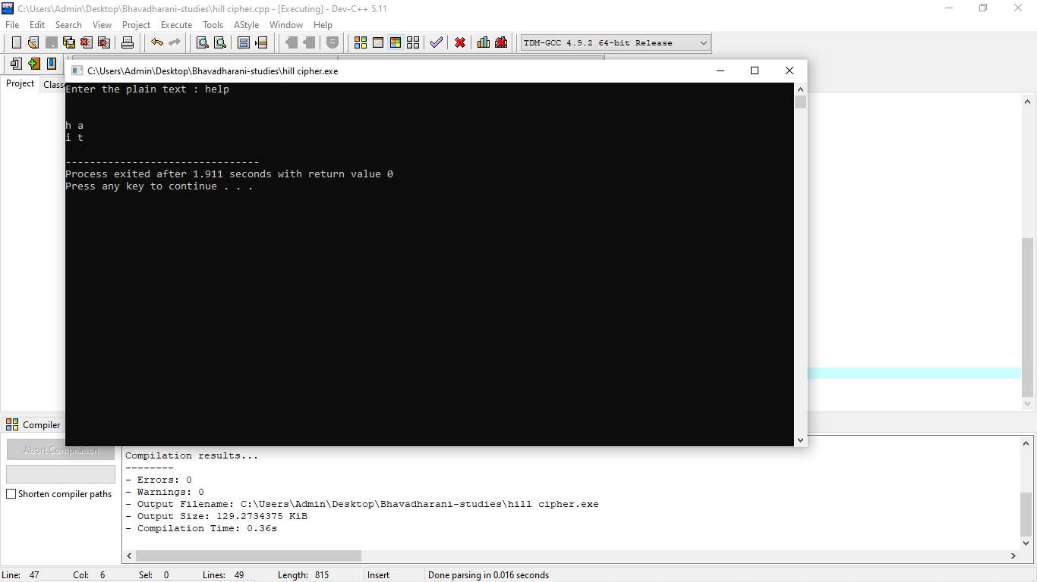

**RESULT:**

Thus the hill cipher substitution technique had been implemented successfully in C.

**EX. NO: 4**

**AIM:**

# IMPLEME TATION OF VIGENERE CIPHER

To implement the Vigenere Cipher substitution technique using C program.

**DESCRIPTION:**

To encrypt, a table of alphabets can be used, termed a tabula recta, Vigenère square,

or Vigenère table. It consists of the alphabet written out 26 times in different rows, each

alphabet shifted cyclically to the left compared to the previous alphabet, corresponding to the 26 possible Caesar ciphers. At different points in the encryption process, the cipher uses a

different alphabet from one of the rows. The alphabet used at each point repeating keyword.

depends on a

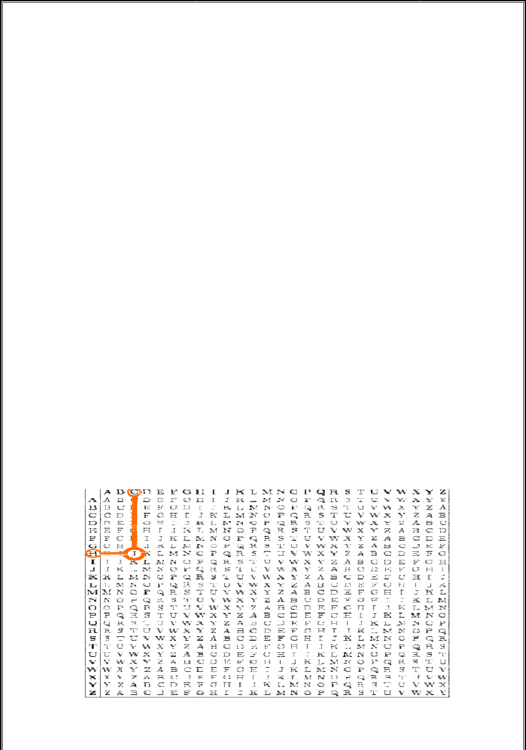

Each row starts with a key letter. The remainder of the row holds the letters A to Z. Although there are 26 key rows shown, you will only use as many keys as there are unique letters in the key string, here just 5 keys, {L, E, M, O, N}. For successive letters of the message, we are going to take successive letters of the key string, and encipher each message letter using its corresponding key row. Choose the next letter of the key, go al ong that row to find the column heading that matches the message character; the letter at the intersection of [key-row, msg-col] is the enciphered letter.

**EXAMPLE:**

**ALGORITHM:**

**STEP-1:** Arrange the alphabets in row and column of a 26*26 matrix.

**STEP-2:** Circulate the alphabets in each row to position left such that the first letter is attached to last.

**STEP-3:** Repeat this process for all 26 rows and construct the final key matrix.

**STEP-4:** The keyword and the plain text is read from the user.

**STEP-5:** The characters in the keyword are repeated sequentially so as to match with that of the plain text.

**STEP-6:** Pick the first letter of the plain text and that of the keyword as the row indices and column indices respectively.

**STEP-7:** The junction character where these two meet forms the cipher character.

**STEP-8:** Repeat the above steps to generate the entire cipher text.

**PROGRAM: (Vigenere Cipher)**

#include<stdio.h>

#include<string.h>

int main(){

char plain

char key;

printf(“Enter the plain text : “);

scanf(“%s”,plain);

printf(“Enter the key value : “);

scanf(“%s”,key);

char alpha[]="abcdefghijklmnopqrstuvwxyz";

int j=0;

char ak[100];

int i=0;

while(i<strlen(plain)){

ak[i]=key[j];

j++;

if(j==strlen(key)){

j=0;

}

i++;

}

printf("Encrypted value : ");

for(int i=0;i<strlen(plain);i++){

int sum=0;

for(int k=0;k<26;k++){

if(plain[i]==alpha[k]){

sum+=k;

}

if(ak[i]==alpha[k]){

sum+=k;

}

}

printf("%c",alpha[sum%26]);

}

}

**OUTPUT** :

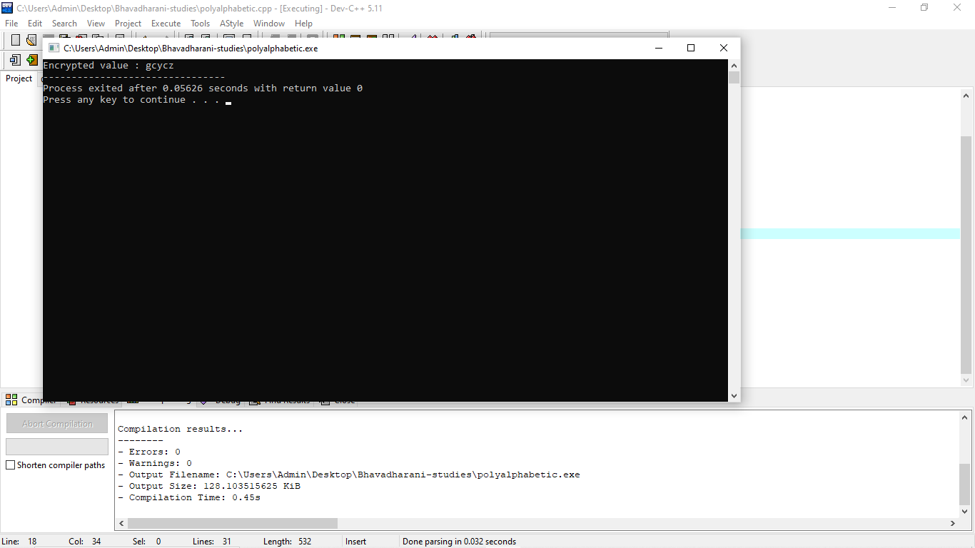

**RESULT:**

Thus the Vigenere Cipher substitution technique had been implemented successfully.

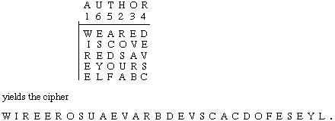

**EX. NO: 5**

# IMPLEMENTATION OF RAIL FENCE – ROW & COLUMN TRANSFORMATION TECHNIQUE

**AIM:**

To write a C program to implement the rail fence transposition technique.

**DESCRIPTION:**

In the rail fence cipher, the plain text is written downwards and diagonally on successive "rails" of an imaginary fence, then moving up when we reach the bottom rail. When we reach the top rail, the message is written downwards again until the whole plaintext is written out. The message is then read off in rows.

**EXAMPLE:**

**ALGORITHM:**

**STEP-1:** Read the Plain text.

**STEP-2:** Arrange the plain text in row columnar matrix format.

**STEP-3:** Now read the keyword depending on the number of columns of the plain text.

**STEP-4:** Arrange the characters of the keyword in sorted order and the corresponding columns of the plain text.

**STEP-5:** Read the characters row wise or column wise in the former order to get the cipher text.

**PROGRAM: (Rail Fence)**

#include<stdio.h>

#include<string.h>

#include<stdlib.h>

char *plainTextToCipherText(char plainText[],int n)

{

int i,j,counter,limit,index=0,len;

char *cipherText;

len=strlen(plainText);

cipherText=(char*)malloc(sizeof(char)*(len+1));

for(i=0;i<n;i++)

{

counter=0;

for(j=i;j<len;j+=limit)

{

cipherText[index++]=plainText[j];

if(i==0 || i==n-1)

limit=2*n-2;

else if(counter%2==0)

limit=2*(n-i-1);

else

limit=2*i;

if(limit<=0)

break;

counter++;

}

}

cipherText[index]='\0';

return cipherText;

}

int main()

{

int n;

char plainText[100];

printf("Enter the plain text : ");

scanf("%s",plainText);

printf("Enter the value of n : ");

scanf("%d",&n);

printf("%s\n",plainTextToCipherText(plainText,n));

return 0;

}

# OUTPUT:

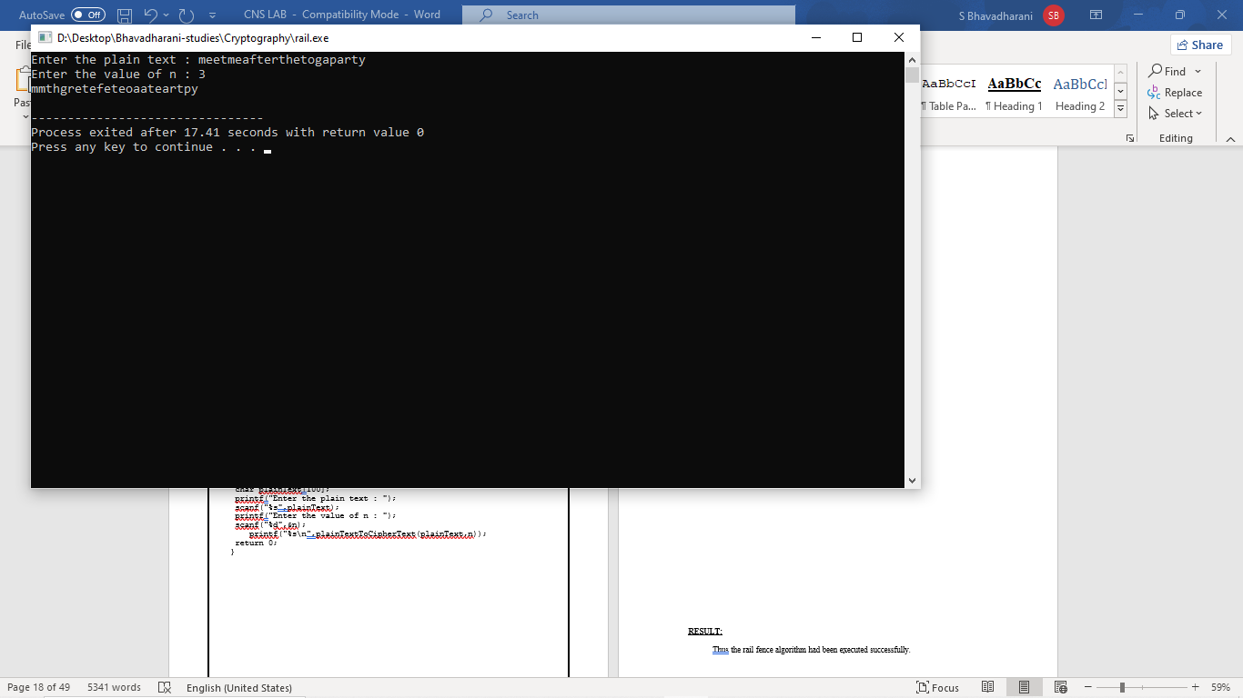

**RESULT:**

Thus the rail fence algorithm had been executed successfully.

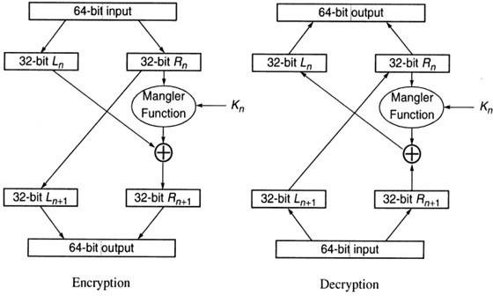

**EX. NO: 6 IMPLEMENTATION OF DES**

**AIM:**

To write a C program to implement Data Encryption Standard (DES) using C Language.

**DESCRIPTION:**

DES is a symmetric encryption system that uses 64-bit blocks, 8 bits of which are used for parity checks. The key therefore has a "useful" length of 56 bits, which means that only 56 bits are actually used in the algorithm. The algorithm involves carrying out combinations, substitutions and permutations between the text to be encrypted and the key, while making sure the operations can be performed in both directions. The key is ciphered on 64 bits and made of 16 blocks of 4 bits, generally denoted k1 to k16. Given that "only" 56 bits are actually used for encrypting, there can be 256 different keys.

**The main parts of the algorithm are as follows:**

* Fractioning of the text into 64-bit blocks
* Initial permutation of blocks
* Breakdown of the blocks into two parts: left and right, named L and R
* Permutation and substitution steps repeated 16 times
* Re-joining of the left and right parts then inverse initial permutation

**EXAMPLE:**

**ALGORITHM:**

**STEP-1:** Read the 64-bit plain text.

**STEP-2:** Split it into two 32-bit blocks and store it in two different arrays.

**STEP-3:** Perform XOR operation between these two arrays.

**STEP-4:** The output obtained is stored as the second 32-bit sequence and the original second 32-bit sequence forms the first part.

**STEP-5:** Thus the encrypted 64-bit cipher text is obtained in this way. Repeat the same process for the remaining plain text characters.

**PROGRAM :**

**#include <stdio.h>**

**#include <stdint.h>**

**void des_encrypt(uint64_t plainText, uint64_t key, uint64_t *cipherText);**

**void print_binary(uint64_t num);**

**int main() {**

**uint64_t plainText, key, cipherText;**

**printf("Enter the 64-bit plaintext: ");**

**scanf("%llx", &plainText);**

**printf("Enter the 64-bit encryption key: ");**

**scanf("%llx", &key);**

**des_encrypt(plainText, key, &cipherText);**

**printf("\nPlaintext: ");**

**print_binary(plainText);**

**printf("\nKey: ");**

**print_binary(key);**

**printf("\nCiphertext: ");**

**print_binary(cipherText);**

**return 0;**

**}**

**void des_encrypt(uint64_t plainText, uint64_t key, uint64_t *cipherText) {**

**\*cipherText = plainText;**

**}**

**void print_binary(uint64_t num) {**

**for (int i = 63; i >= 0; i--) {**

**uint64_t bit = (num >> i) & 1;**

**printf("%llu", bit);**

**if (i % 8 == 0)**

**printf(" ");**

**}**

**printf("\n");**

**}**

**OUTPUT:**

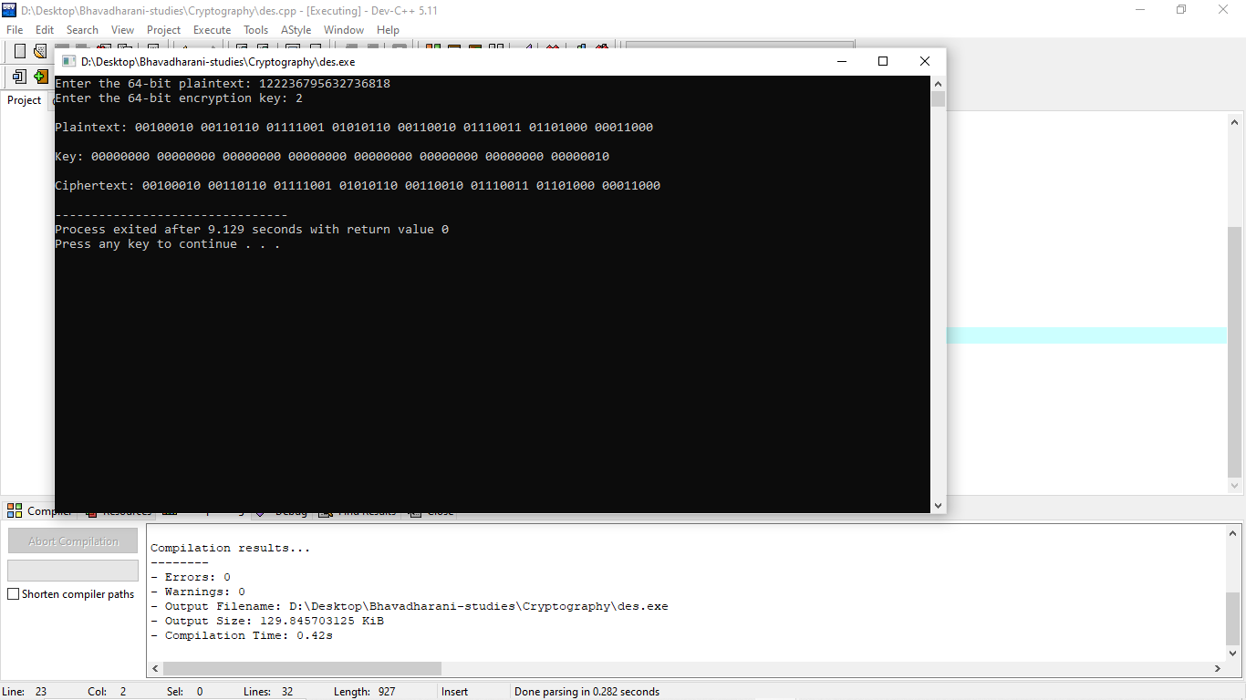

**RESULT:**

Thus the data encryption standard algorithm had been implemented successfully using C language.

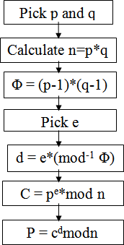

**EX. NO: 7 IMPLEMENTATION OF RSA**

**AIM:**

To write a C program to implement the RSA encryption algorithm.

**DESCRIPTION:**

RSA is an algorithm used by modern computers to encrypt and decrypt messages. It is an asymmetric cryptographic algorithm. Asymmetric means that there are two different keys. This is also called public key cryptography, because one of them can be given to everyone. A basic principle behind RSA is the observation that it is practical to find three very large positive integers e, d and n such that with modular exponentiation for all integer m:

**(me)d = m (mod n)**

The public key is represented by the integers n and e; and, the private key, by the integer d. m represents the message. RSA involves a public key and a private key. The public key can be known by everyone and is used for encrypting messages. The intention is that messages encrypted with the public key can only be decrypted in a reasonable amount of time using the private key.

**EXAMPLE:**

**ALGORITHM:**

**STEP-1:** Select two co-prime numbers as p and q.

**STEP-2:** Compute n as the product of p and q.

**STEP-3:** Compute (p-1)*(q-1) and store it in z.

**STEP-4:** Select a random prime number e that is less than that of z.

**STEP-5:** Compute the private key, d as e * mod-1(z).

**STEP-6:** The cipher text is computed as messagee * mod n.

**STEP-7:** Decryption is done as cipherdmod n.

**PROGRAM: (RSA)**

#include<stdio.h>

#include<string.h>

#include<math.h>

int main(){

int p,q,m,n,dn,e,c,de,x,y;

printf("Enter the value of p : ");

scanf("%d",&p);

printf("Enter the value of q : ");

scanf("%d",&q);

printf("Enter the value of m : ");

scanf("%d",&m);

printf("Enter the value of e : ");

scanf("%d",&e);

n=p*q;

dn=(p-1)*(q-1);

int d;

for(int i=1;i<dn;i++){

if(((e%dn)*(i%dn))%dn==1){

d=i;

break;

}

}

x=pow(m,e);

c=x%n;

y=pow(c,d);

de=y%n;

printf("Encrypted text : %d ", c);

printf("\nDecrypted text : %d ", m);

}

**OUTPUT :**

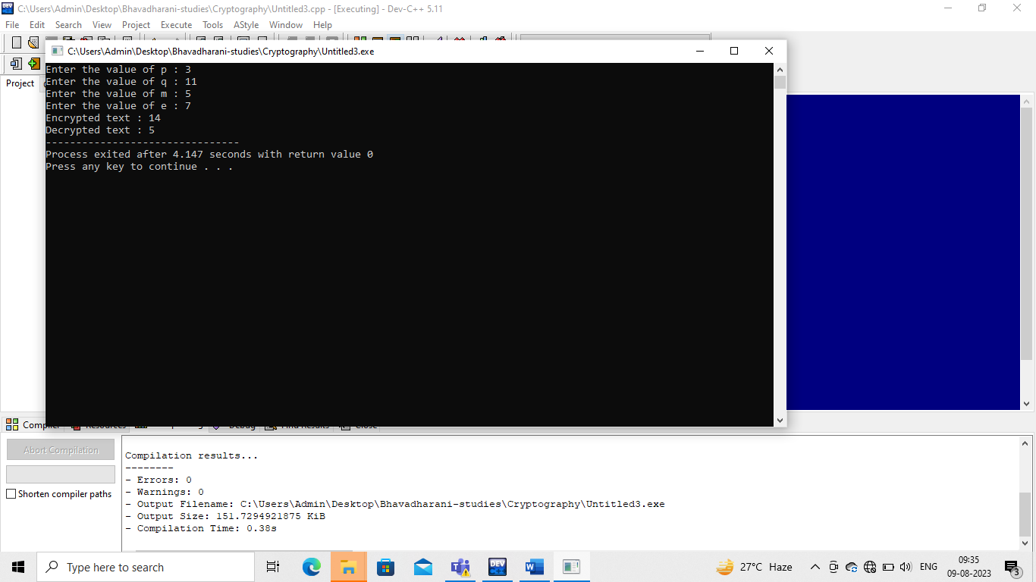

**RESULT:**

Thus the C program to implement RSA encryption technique had been implemented successfully.

**EX. NO: 8**

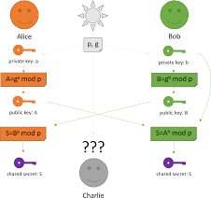

# IMPLEMENTATION OF DIFFIE HELLMAN KEY EXCHANGE ALGORITHM

**AIM:**

To implement the Diffie-Hellman Key Exchange algorithm using C language.

**DESCRIPTION:**

Diffie–Hellman Key Exchange establishes a shared secret between two parties that can be used for secret communication for exchanging data over a public network. It is primarily used as a method of exchanging cryptography keys for use in symmetric encryption algorithms like AES. The algorithm in itself is very simple. The process begins by having the two parties, Alice and Bob. Let's assume that Alice wants to establish a shared secret with Bob.

**EXAMPLE:**

**ALGORITHM:**

**STEP-1:** Both Alice and Bob shares the same public keys g and p.

**STEP-2:** Alice selects a random public key a.

**STEP-3:** Alice computes his secret key A as ga mod p.

**STEP-4:** Then Alice sends A to Bob.

**STEP-5:** Similarly Bob also selects a public key b and computes his secret key as B and sends the same back to Alice.

**STEP-6:** Now both of them compute their common secret key as the other one‟s secret key power of a mod p.

**PROGRAM: (Diffie Hellman Key Exchange)**

#include<stdio.h>

#include<string.h>

#include<math.h>

int main(){

int a,q,xa,xb,ya,yb,x,y,ka,kb,m,n;

printf("Enter the value of a : ");

scanf("%d",&a);

printf("Enter the value of q : ");

scanf("%d",&q);

printf("Enter the value of xa : ");

scanf("%d",&xa);

printf("Enter the value of xb : ");

scanf("%d",&xb);

x=pow(a,xa);

ya=x%q;

y=pow(a,xb);

yb=y%q;

m=pow(yb,xa);

ka=m%q;

n=pow(ya,xb);

kb=n%q;

printf("Secret key of user A : %d ", ka);

printf("\nSecret key of user B : %d ", kb);

}

**OUTPUT:**

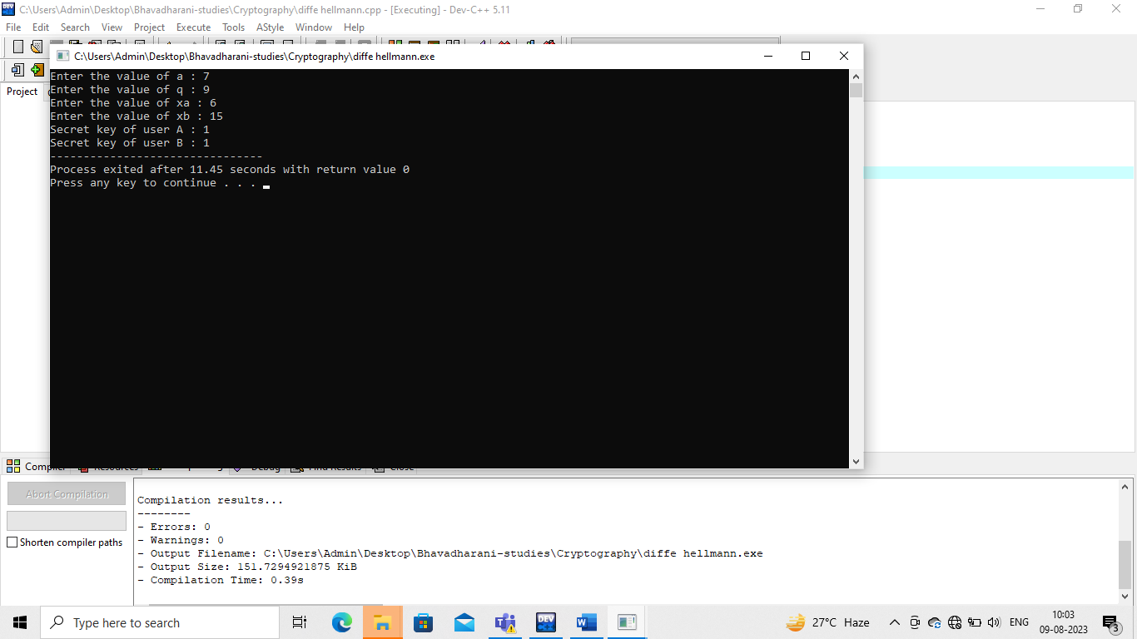

**RESULT:**

Thus the Diffie-Hellman key exchange algorithm had been successfully implemented using C.

**EX. NO: 9**

# IMPLEMENTATION OF MD5

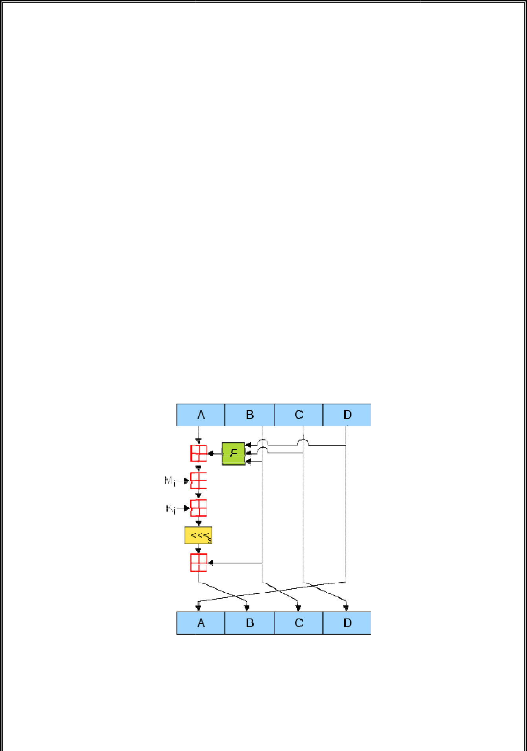

**AIM:**

To write a C program to implement the MD5 hashing technique.

**DESCRIPTION:**

MD5 processes a variable-length message into a fixed-length output of 128 bits. The input message is broken up into chunks of 512-bit blocks. The message is pa dded so that its length is divisible by 512. The padding works as follows: first a single bit, 1, is appended to the end of the message. This is followed by as many zeros as are required to bring the length of the message up to 64 bits less than a multiple of 512. The remaining bits are filled up with 64 bits representing the length of the original message, modulo 264.The main MD5 algorithm operates on a 128-bit state, divided into four 32-bit words, denoted A, B, C, and D. These are initialized to certain fixed constants. The main algorithm then uses each 512-bit message block in turn to modify the stat e.

**EXAMPLE:**

**ALGORITHM:**

**STEP-1:** Read the 128-bit plain text.

**STEP-2:** Divide into four blocks of 32-bits named as A, B, C and D.

**STEP-3:** Compute the functions f, g, h and i with operations such as, rotations, permutations, etc,.

**STEP-4:** The output of these functions are combined together as F and performed circular shifting and then given to key round.

**STEP-5:** Finally, right shift of „s‟ times are performed and the results are combined together to produce the final output.

**PROGRAM:( MD5)**

**import java.math.BigInteger;**

**import java.security.MessageDigest;**

**import java.security.NoSuchAlgorithmException;**

**import java.util.Scanner;**

**public class MD5 {**

**public static String getMd5(String input)**

**{**

**try {**

**MessageDigest md = MessageDigest.getInstance("MD5");**

**byte[] messageDigest = md.digest(input.getBytes());**

**BigInteger no = new BigInteger(1, messageDigest);**

**String hashtext = no.toString(16);**

**while (hashtext.length() < 32) {**

**hashtext = "0" + hashtext;**

**}**

**return hashtext;**

**}**

**catch (NoSuchAlgorithmException e) {**

**throw new RuntimeException(e);**

**}**

**}**

**public static void main(String args[]) throws NoSuchAlgorithmException**

**{**

**Scanner sc= new Scanner(System.in);**

**System.out.println("Enter the plain text : ");**

**String s = sc.nextLine();**

**System.out.println("Your HashCode Generated by MD5 is: " + getMd5(s));**

**}**

**}**

**OUTPUT:**

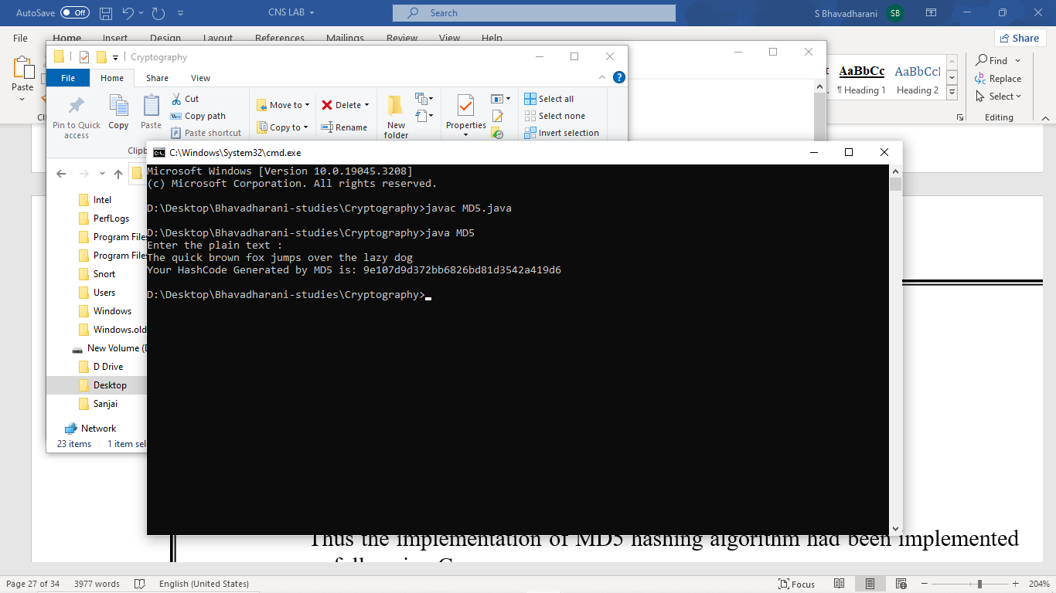

**RESULT:**

Thus the implementation of MD5 hashing algorithm had been implemented successfully using C.

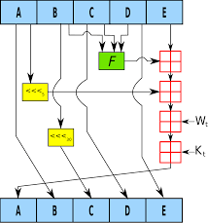

**EX. NO: 10 IMPLEMENTATION OF SHA-I**

**AIM:**

To implement the SHA-I hashing technique using C program.

**DESCRIPTION:**

In cryptography, SHA-1 (Secure Hash Algorithm 1) is a cryptographic hash function. SHA-1 produces a 160-bit hash value known as a message digest. The way this algorithm works is that for a message of size < 264 bits it computes a 160-bit condensed output called a message digest. The SHA-1 algorithm is designed so that it is practically infeasible to find two input messages that hash to the same output message. A hash function such as SHA-1 is used to calculate an alphanumeric string that serves as the cryptographic representation of a file or a piece of data. This is called a digest and can serve as a digital signature. It is supposed to be unique and non-reversible.

**EXAMPLE:**

**ALGORITHM:**

**STEP-1:** Read the 256-bit key values.

**STEP-2:** Divide into five equal-sized blocks named A, B, C, D and E.

**STEP-3:** The blocks B, C and D are passed to the function F.

**STEP-4:** The resultant value is permuted with block E.

**STEP-5:** The block A is shifted right by „s‟ times and permuted with the result of step-4.

**STEP-6:** Then it is permuted with a weight value and then with some other key pair and taken as the first block.

**STEP-7:** Block A is taken as the second block and the block B is shifted by „s‟ times and taken as the third block.

**STEP-8:** The blocks C and D are taken as the block D and E for the final output.

**PROGRAM: (Secure Hash Algorithm)**

import java.math.BigInteger;

import java.security.MessageDigest;

import java.security.NoSuchAlgorithmException;

import java.util.Scanner;

public class SHA {

public static String encryptThisString(String input)

{

try {

MessageDigest md = MessageDigest.getInstance("SHA-1");

byte[] messageDigest = md.digest(input.getBytes());

BigInteger no = new BigInteger(1, messageDigest);

String hashtext = no.toString(16);

while (hashtext.length() < 32) {

hashtext = "0" + hashtext;

}

return hashtext;

}

catch (NoSuchAlgorithmException e) {

throw new RuntimeException(e);

}

}

public static void main(String args[]) throws NoSuchAlgorithmException

{

Scanner sc=new Scanner(System.in);

System.out.println("Enter the plain text : ");

String s1 = sc.nextLine();

System.out.println("HashCode Generated by SHA-1 for: ");

System.out.println("\n" + s1 + " : " + encryptThisString(s1));

}

}

**OUTPUT:\**

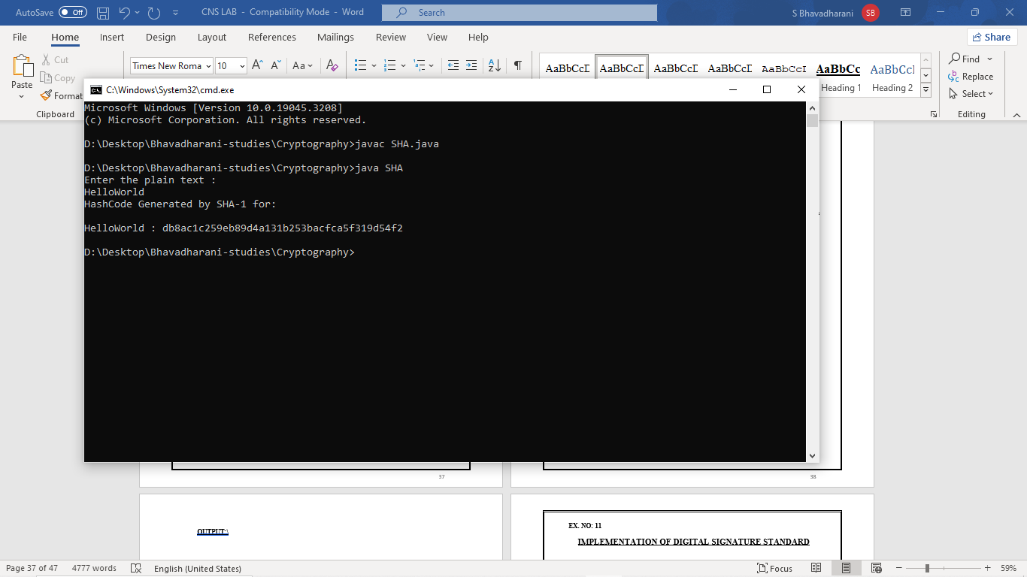

**RESULT:**

Thus the SHA-1 hashing technique had been implemented successfully.

**EX. NO: 11**

**IMPLEMENTATION OF DIGITAL SIGNATURE STANDARD**

**AIM:**

To write a C program to implement the signature scheme named digital signature

standard (Euclidean Algorithm).

**ALGORITHM:**

**STEP-1:** Alice and Bob are investigating a forgery case of x and y.

**STEP-2:** X had document signed by him but he says he did not sign that document digitally.

**STEP-3:** Alice reads the two prime numbers p and a.

**STEP-4:** He chooses a random co-primes alpha and beta and the x‟s original signature x.

**STEP-5:** With these values, he applies it to the elliptic curve cryptographic equation to obtain y.

**STEP-6:** Comparing this „y‟ with actual y‟s document, Alice concludes that y is a forgery.

**PROGRAM: (Digital Signature Standard)**

**OUTPUT:**

**RESULT:**

Thus the simple Code Optimization techniques had been implemented successfully.

**EX. NO: 12**

# WORKING WITH SNORT TOOL TO DEMONSTRATE INTRUSION DETECTION SYSTEM

**AIM:**

Snort is an open source network intrusion detection system (NIDS) and it is a packet sniffer that monitors network traffic in real time.

**INTRODUCTION:**

**INTRUSION DETECTION SYSTEM :**

Intrusion detection is a set of techniques and methods that are used to detect suspicious activity both at the network and host level. Intrusion detection systems fall into two basic categories:

* Signature-based intrusion detection systems
* Anomaly detection systems.

Intruders have signatures, like computer viruses, that can be detected using software. You try to find data packets that contain any known intrusion-related signatures or anomalies related to Internet protocols. Based upon a set of signatures and rules, the detection system is able to find and log suspicious activity and generate alerts.

Anomaly-based intrusion detection usually depends on packet anomalies present in protocol header parts. In some cases these methods produce better results compared to signature-based IDS. Usually an intrusion detection system captures data from the network and applies its rules to that data or detects anomalies in it. Snort is primarily a rule-based IDS, however input plug-ins are present to detect anomalies in protocol headers.

**SNORT TOOL:**

Snort is based on libpcap (for library packet capture), a tool that is widely used in TCP/IPtraffic sniffers and analyzers. Through protocolanalysis and content searching and matching, Snort detects attack methods, including denial of service, buffer overflow, CGI attacks, stealthport scans, and SMB probes. When suspicious behavior is detected, Snort sends a real-time alert to syslog, a separate 'alerts' file, or to apop-up window.

Snort is currently the most popular free network intrusion detection software. The advantages of Snort are numerous. According to the snort web site, “It can perform protocol

analysis, content searching/matching, and can be used to detect a variety of attacks and probes, such as buffer overflow, stealth port scans, CGI attacks, SMB probes, OS fingerprinting attempts, and much more” (Caswell).

One of the advantages of Snort is its ease of configuration. Rules are very flexible, easily written, and easily inserted into the rule base. If a new exploit or attack is found a rule for the attack can be added to the rule base in a matter of seconds. Another advantage of snort is that it allows for raw packet data analysis.

**SNORT can be configured to run in three modes:**

* 1. Sniffer mode
  2. Packet Logger mode
  3. Network Intrusion Detection System mode

1. **Sniffer mode**
   * **Snort –v** Print out the TCP/IP packets header on the screen
   * **Snort –vd** show the TCP/IP ICMP header with application data in transmit
2. **Packet Logger mode**
   * **snort –dev –l c:\log** [create this directory in the C drive] and snort will automatically know to go into packet logger mode, it collects every packet it sees and places it in log directory.
   * **snort –dev –l c:\log –h ipaddress/24**:This rule tells snort that you want to print out the data link and TCP/IP headers as well as application data into the log directory. snort –l c:\log –b This is binary mode logs everything into a single file.
3. **Network Intrusion Detection System mode**
   * **snort –d c:\log –h ipaddress/24 –c snort.conf** This is a configuration file applies rule to each packet to decide it an action based upon the rule type in the file.
   * **Snort –d –h ipaddress/24 –l c:\log –c snort.conf** This will cnfigure snort to run in its most basic NIDS form, logging packets that trigger rules specifies in the snort.conf.

**PROCEDURE:**

**INSTALLATION OF SNORT :**

**STEP 1 :** Download the Snort using the link , <https://www.snort.org/downloads/snort/snort-2.9.20-1.f35.x86_64.rpm> .

**STEP 2** : Complete the installation .

**STEP 3** : Install NPcap 1.7 using the given link , <https://npcap.com/#download> .

**STEP 4** : Complete installation

**STEP 5** : Open Command Prompt

COMMANDS TO BE GIVEN IN COMMAND PROMPT :

**C:\>cd..**

**C:\>cd..**

**C:\>cd Snort**

**C:\Snort>cd bin**

**C:\Snort\bin>Snort -v**

**OUTPUT** :

**RESULT:**

Thus the demonstration of the instruction detection using Snort tool was done successfully.